Cloud fundamentals

Lesson 1
Traditional infrastructure:
- Provision room for datacenter
- Provide redundant power and internet
- buy and install hardware
- Cabling
- Maintain backups and infrastructure
- physical/data security
The old way:
- buy and install hardware
- buy, install and configur OS
- buy/download software
- install and configure software
- Maintain software and runtime updates
- Guess what the requirements will be in the future
- Maintain backup
- Create developer’s environment
Ai, company wilt scalability maar de plaats is op in het kleine serverkot
Solution: cloud computing
Using resources from a cloud provider’s HUGE pool of virtualized hardware recourses as a service
On demand, self service, instant delivery of IT recourses and services via the internet
Build temporary and disposable infrastructure that fits your needs at any time. Scale out or dispose resources depending on the real time requirements. Quickly adapt to changes in the demands/requirements.
Cloud deploys all over the world, lower latency for end users

Software in the cloud
- no need to install software on you local computer
- user a modern webbrowser to use the application over the internet
- Infrastructure, OS, Software Development, ….
- Provider manages all the potential technical issues, such as data, middleware, servers, storage, updates
- You can use this software with a subscription

Platform as a service
Just provides the software for you, no need to worry about that.

Service models:
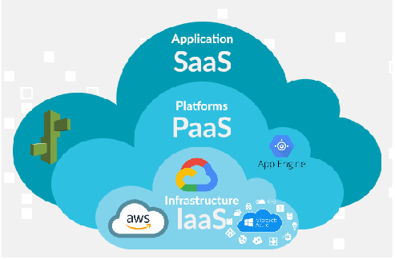

Infrastructure as a Service:
- Physical hardware and hypervisors are managed by cloud service provider
- Clients are responsible for managing aspects such as applications, runtime, OS, middleware, and dataa
- Complete control over the entire virtual infrastructure, including things such as servers, networking, …
- Build your own virtual datacenter

Platform as a service
- Provides a framework for devlopers that they
- Provides a platform for software creation
- Developers can concentrate on building the software while not having to worry about runtimes, operating systems, software updates, …

Metal as a service
- provisioning of physical hardware as a services
- Dedicated fully to your project with 100% of its resources available for your configuration
- Reliable when deploying mission-critical projects with predictable performance
- offers raw processing power for high performance
- offers substantial graphic processing units capacity
- results in low latency compare to shared cloud solutions.

XAAS → anything as a service

Services

Storage:
- File storage
- File archive
- Data transfer to cloud
- Virtual hard drives
- Databases

Compute:
- Virtual machines
- Containers
- Auto scaling
- Serverless
- Virtual desktop

Networking:
- Building virtual datacenters
- Load balancing
- Connect cloud datacenter
- data transfer between servcies

Advantages:

Variable cost vs. Capital expense
- no up-front investment
- Pay only what you use

Economy of scale
- public cloud providers can get a lower variable cost because the hardware is used by many customers
- they can offer very high availability and redundancy
- Virtually unlimited recourses available to customers

Scalability and elasticity
- Cloud infrastructure can easily scale
- Manual or automatic

Focus on business priorities
- hardware infrastructure, redundancy, availability are managed and guaranteed by cloud service provider
- updates, failures, adding hardware is done by cloud service provider
- businesses can focus on their core business

Go global in minutes
- Deploy application in multiple locations
- Deploy application close to users = low latency

Infrastructure as code
- Managing and provisioning computer data centers and configuration through machine-readable, definition files
- Configuration management
- orchestration
- disposable infrastructure
- GIT

Types of cloud:

Public
- all hardware, software and other
- you share the same hardware
- access services and manage your account
- near-unlimited scalability
- high reliability
- pay as you go
but:
- no hardware management
- Sensitive data may be prohibited from beeing stored on public cloud or in foreign country

private
- Computing resources used exclusively by one business or organization
- physically located at organization’s on-site datacenter or hosted by a third- party service provider
- maintained on a privae networking
- government agencies, financial institutions, ….
- sensitive, business-critical operations
- more flexibility,
- infrastructure investment

community
Community of companies/customers with common tasks share a cloud infrastructure
- safety requirements
- policies
- compliance to specific requirements

Hybrid cloud
- combination of public, private and/or community cloud
- data and applications can move between private and public clouds
- application or resource runs in the private cloud until there is a spike in demand at which point the organization can “burst through” to the public cloud to tap into additional computing resources.
- Sensitive data can be stored in private cloud

Virtualization
- a layer of abstraction between computer hardware systems and the software running on them.
- logically dividing resources

Microservices
- small applications that interact with each other over messaging protocol
- you build it – you own it
- every team chooses technology that is best suited for their application
- continues development/continues deployment
- infrastructure as code

